category | product | img | desc
Audio | Volume-sensitive Over-ear Headphones | 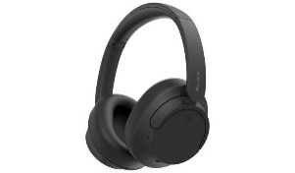  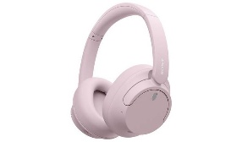 | Designed for comfort, over-ear with soft-cushioned ear pads, these wireless headphones protect delicate eardrums of growing children with their volume control, prioritising hearing health during long durations of use. Wireless design allows children to keep distance from the screens.  - Wireless/Bluetooth  - Volume limit  - 12-hour battery life  - 3-hour charging time  - Foldable, perfect for travel and gaming  - Microphone included  - Headband adjustable  Age rating: 6+
 | Lightweight Wired Headphones | 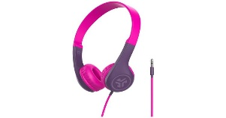  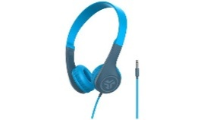 | For sensitive heads, these lightweight headphones make sure no extra weight causes discomfort. Designed to alleviate pressure from ears and heads, making long duration wear more endurable. Cushioned and on ear allows these headphones to be worn comfortably by all ages.  - Wired (3.5 mm jack)  - Lightweight  - Headband adjustable  Age rating: 4+
 | Small Wireless Over-ear Headphones | 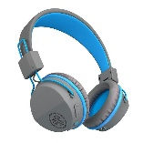  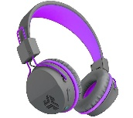 | For smaller ears and heads, these small headphones make sure of comfort for long durations. Over-ear ensures headphones stay on and do not cause discomfort or pain over time. Wireless design allows children to keep distance from the screens.  - Wireless/Bluetooth  - 6-hour battery life  - 3-hour charging time  - Foldable, perfect for travel and gaming  - Headband adjustable  Age rating: 6+
 | Wireless Microphone Over-ear Headset | 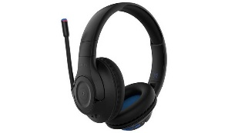  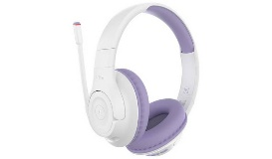 | Microphone Headset allows kids to engage with games without the clutter of many devices. All-in-one ensures the best experience with upmost convenience. Over-ear ensures headphones stay on and do not cause discomfort or pain over time. Wireless design allows children to keep distance from the screens.  - Wireless/Bluetooth  - 8-hour battery life  - 4-hour charging time  - Foldable, perfect for travel and gaming  - Microphone included  - Headband adjustable  Age rating: 8+
 | Clip-on Microphone | 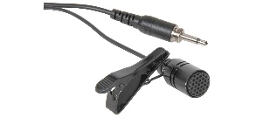 | Already own headphones or just looking for the most convenient option? This wired/wireless clip-on microphone allows ease of use. Plug into headset/device or connect via Bluetooth, you are able to instantly use with little to no set up.  - Wired/wireless/Bluetooth  - 4-hour battery life  - 2-hour charge time  - 3.5mm jack  - Easy clip  - Clear audio  - Background noise cancellation  Age rating: 5+
Controllers | Small Handheld Controller | 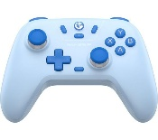 | Small sized controller made for small hands, preventing overstretch and cramps. For younger children, all buttons are accessible for smaller reaches. Compatible with all consoles and devices. Wireless design allows children to keep distance from the screens.  - 15-hour battery life  - 3-hour charge time  - Wireless  Age rating: 3+
 | Wireless Ergonomic Controller | 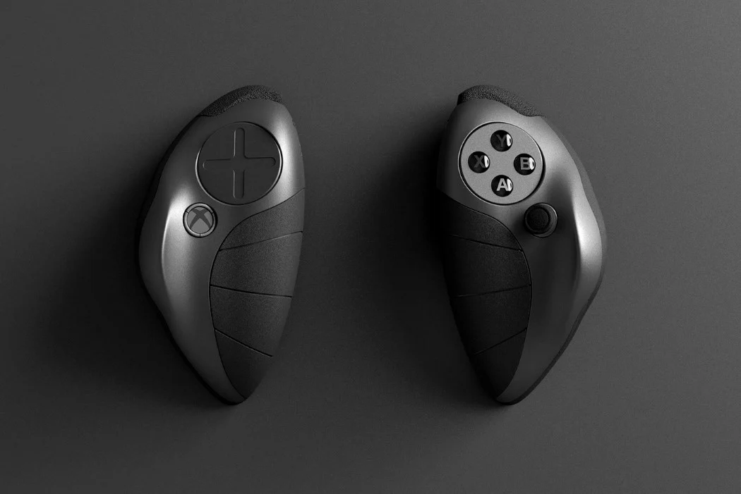 | Ergonomically designed for better hand muscle and motor development, prioritising strain reduction in arms and wrists, this design allows for hands and arms to rest at a natural shoulder-width distance, reducing pressure between shoulder blades and allowing for better posture overall. Comfortable and shaped to fit perfectly in the palm and fingers are allowed to sit at rest position. Wireless design allows children to keep distance from the screens. Compatible with all devices.  - 15-hour battery life  - 4-hour charge time  - Wireless  Age rating: 6+
 | Enlarged Button Controller | 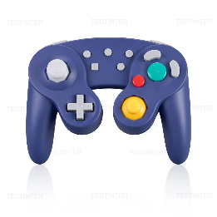 | Bright colours for visual aid and larger buttons and joysticks for ease of use. The distinguishable buttons allow children to become more accustomed to the devices and larger buttons allows eyes not to strain whilst using. Wireless design allows children to keep distance from the screens. Compatible with all devices.  - 8-hour battery life  - 2-hour charge time  - Wireless  - Colourful  - Lightweight  Age rating: 3+
 | Ergonomic Cushioned Case for Controller | 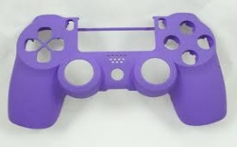  (pretend this is cushioned) | Already own a controller but want to make it more comfortable? This case allows for a gentler hold, cushioned and soft means palms clenching the controller will not hurt and long-duration usage will cause less strain. The case is shaped and padded to fit an ergonomic shape, supporting the hands natural position. Compatible with all devices.  - Colourful  - Lightweight  - Ergonomic  - Soft  Age rating: 3+
 | Trigger Extender Caps | 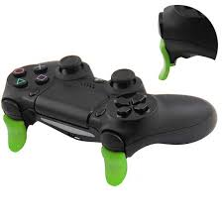 | For hands with difficulty reaching trigger buttons on gaming controllers. Trigger extenders shorten the distance between finger and button, allowing for an easier usage and preventing nay muscle strains in hands and arms. Compatible with PlayStation controllers.  Age rating: 7+
Keyboard and mouse | Ergonomic Keyboard | 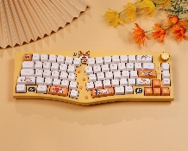 | Prioritising hand and motor health, ergonomically designed keyboard allows for the hand and wrist to sit in its natural position, preventing straining and stretching of muscles and causing discomfort. This design makes sure that motor development is not stunted especially in long-term usage. Wireless design allows children to keep distance from the screens. Compatible with all devices.  - 8-hour battery life  - 2-hour charge time  - Wireless  - Colourful  Age rating: 3+
 | Ergonomic Mouse | 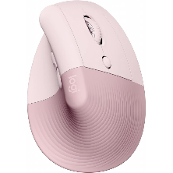 | Prioritising hand and motor health, ergonomically designed mouse allows for the hand and wrist to sit in its natural position, preventing straining and stretching of muscles and causing discomfort. This design makes sure that motor development is not stunted especially in long-term usage. Wireless design allows children to keep distance from the screens. Compatible with all devices.  - 8-hour battery life  - 2-hour charge time  - Wireless  - Colourful  Age rating: 3+
 | Small Keyboard | 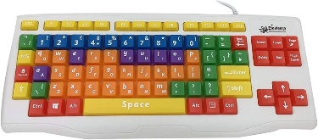 | Bright colours for visually impaired aid. The distinguishable buttons allow children to become more accustomed to the devices and allows eyes not to strain whilst using. Compatible with all devices.  - Wired  - Colourful  - USB  Age rating: 3+
 | Small Mouse | 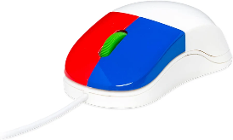 | Bright colours for visually impaired aid. The distinguishable buttons allow children to become more accustomed to the devices and allows eyes not to strain whilst using. Compatible with all devices.  - Wired  - Colourful  - USB  Age rating: 3+
 | Wrist Rest | 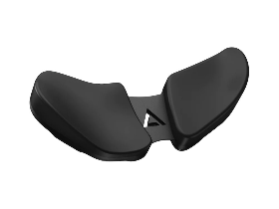 | Prioritising hand and motor health, ergonomically designed wrist rest allows for the hand and wrist to sit in its natural position, preventing straining and stretching of muscles and causing discomfort. This design makes sure that motor development is not stunted especially in long-term usage. Resting takes pressure off joints and muscles, allowing long-duration playtime easier and healthier on the body.  - Cushioned  - Transportable  - Adaptable for all ages  Age rating: 3+
Desks and Chairs | Ergonomic Posture Chair | 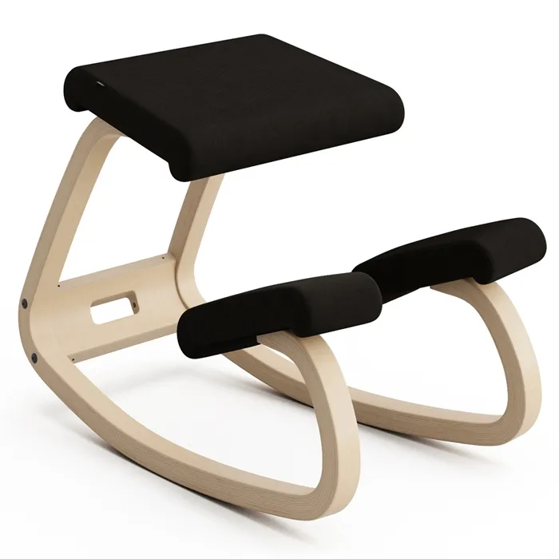 | Ergonomically designed motion chair makes for strengthening core muscles and maintain posture. The cushioned seats allow for comfort regardless the position. The versatile design prevents straining and stretching of muscles and causing discomfort. This design makes sure that motor development is not stunted especially in long-term usage. Promotes healthier habits in the long run.  - Cushioned  - Adaptable  - Good for spinal health  Age rating: 7+
 | Small Gaming Chair | 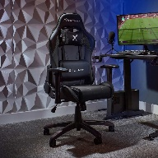 | This smaller chair allows children of all ages to sit comfortably whilst engaging with technology with soft cushions along the body to support the back and neck of the child, posture is maintained, hunching prevented, and muscle pains and sores are avoided.  - Cushioned  - Adjustable  - Supporting back and head  Age rating: 3+
 | Ergonomic Booster Seat | 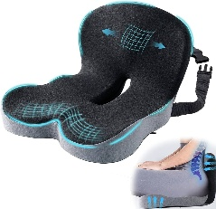 | Already own a chair? This booster seat allows your chair to conform into an ergonomically supportive seat for children, making sure they stay comfortable and healthy. Boosts them to screen height, as well as supports the lower spine and hips, promoting good posture and preventing back aches and sores. Is adaptable to most chairs.  - Cushioned  - Supports lower back  - Ergonomically designed  - Adaptable  Age rating: 3+
 | Height-adjusting Table | 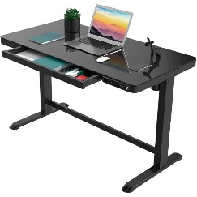 | To allow both standing and seating, adaptable to all heights, this adjustable table allows the screen to meet your eye, making sure there is no straining of sight or neck and back muscles. A slow speed to prevent young children’s injuries, and easily usable by all ages. Promotes healthy habits of standing and movement as well as supporting posture.  - Adjustable  - Durable  - Electric  - Easy to use  Age rating: 5+
 | Adjustable Monitor Stand | 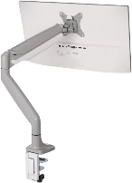 | Compatible with screens of all kinds; tablets, monitors, and phones. This stand allows you to connect any screen to any table and adjust it to you eyeline, preventing eye and neck strains.  Age rating: 3+
Tabletop Accessories | Anti-glare screen protector | 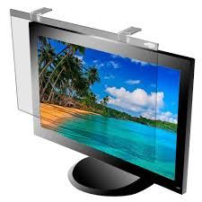 | An easy clip-on screen that prevents eye strains and sores by keeping away harsh lights that bounce off the screens.  Age rating: 3+
 | Screen-time Timer | 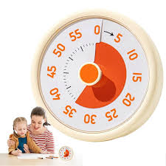 | To make sure healthy habits are kept, discipline is necessary. Our screen-time timer allows self-regulation as well as external management of children’s screen time.  Age rating: 3+
 | Ergonomic I-pad Case | 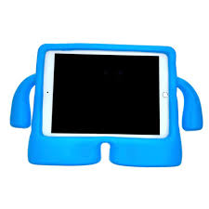 | This ergonomically designed I-pad case allows children to hold their screens and make use of their hand muscles and motor skills, promoting healthy usage and development along long durations.  Age rating: 3+
 | Fidget toy | 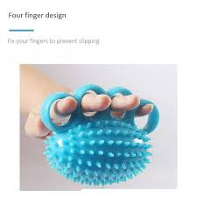 | This fidget toy is squishy and great for relieving stress and tension especially whilst playing. The design promotes usage on motor skills, making use of the muscles in the hand develop. Also offering a quick relief from screens too is a healthy condition.  Age rating: 7+
 | Screen-time Reward Chart | 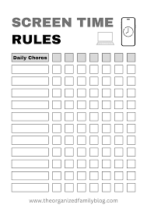 | An easy incentive to maintaining healthy habits, rewards can be collected based on each kids individual preferences and hone regulations on screentime.  Age rating: 3+

